Deadline: Until the right candidate is found
Expected start-date: September 2022
PhD Title: Data-Driven models of Wind Farms

Overview
Operations and Maintenance (O&M) aspects of wind farms are becoming increasingly important. On the other hand there exists extensive data and algorithms to analyse them. The demand for good O&M, including digital twinning aspects can only be impactful when they are implemented in a robut manner and for realistic conditions.
Several algorithms and methods often do not work well in realistic conditions due to the complex processes and physics that govern the responses of these farms – and not all are measured, or equally available.
Under such circumstances, it is important to develop robust, physics-driven models of these farms considering varied levels of available data and existing understanding of how they operate.
This project looks precisely into this aspects by considering physics-driven models which link dynamic responses (mechanical responses and the variability of power over different timestamps) with appropriate models, considering varied data quality, stochasticity and other difficult challenges which current stops our models from achieving what they can. Another aspect is that of the clarity and robustness of these models. Often, the models are not robust, in the sense that their performance levels are not well calibrated or are achievable over only certain combinations of input, rendering their usability to be limited. It is important to develop methods that are more stable, reproducible and available for varied circumstances, even if this means that their accuracy is slightly worse than a method that is too specific.
This project will look into some of these aspects and create benchmark results, which can be used by others in future. We also expect this benchmark to be a go-to for many questions. We intend to engage with the activities of International Energy Agency Wind tasks in this project as well.
Scientifically, a lot of effort will go into understanding how we can move from Data to Dynamics.

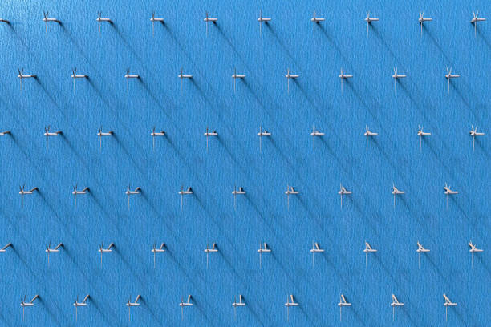
Figure 1.. A wind farm with possibilities of using data-dynamics under a common framework. How do we make the most of data and its relation to the dynamics of this system?

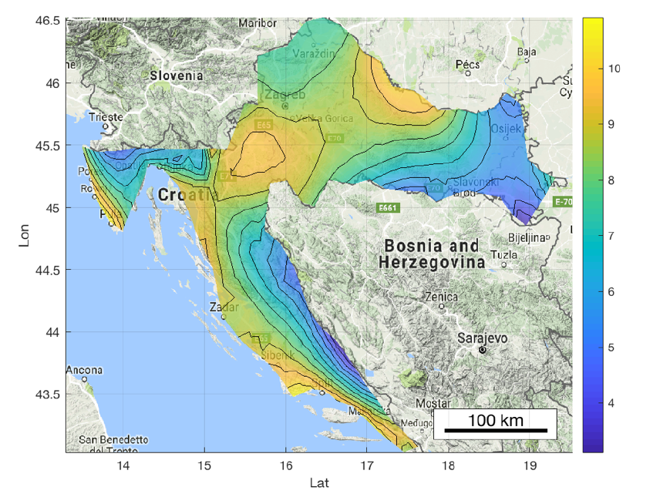
Figure 2. An example of adapting spatial temporal data in this instance on the recorded at 127 meteorological stations across Croatia to its fundamental dynamical system to obtain a spatial field for the temperature over Croatia that as shown incorporates both anisotropic and non-stationary behaviour. How do we link local and global impacts and the complex spatiotemporal behaviour? We cannot solve everything but what is the most reasonable way forward?

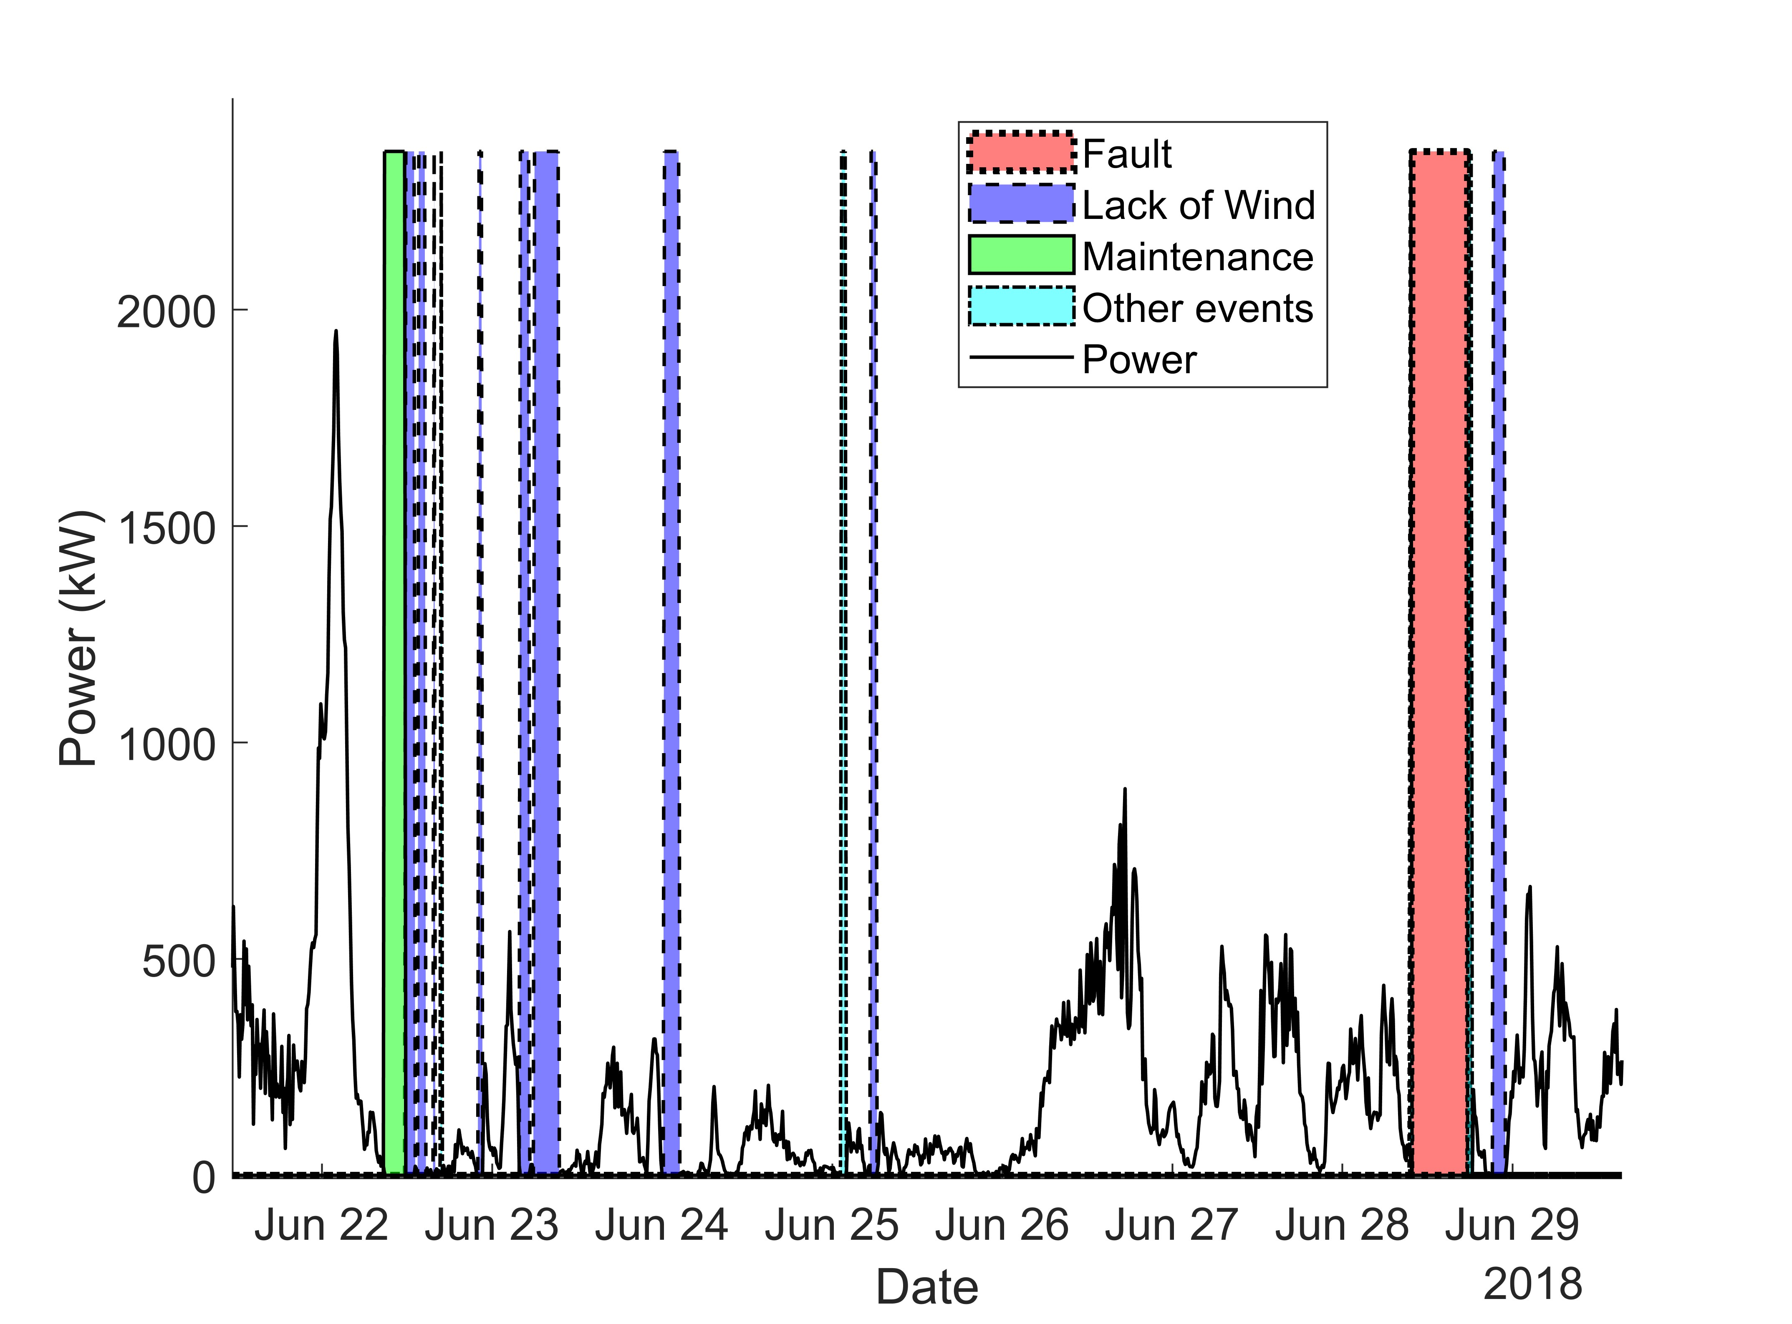
Figure 3. Visualisation of events from wind farm data. How to make such early detection, prediction and O&M better in a physics-aware way?

The position
We are looking for one candidate with a passion for linking fundamental physics and computation. Understanding of good statistics, uncertainty and stochasticity is a big plus. Knowledge of machine learning is fine but we are focusing more on those with fundamental knowledge in computing and physics (including dynamics). A demonstrated work on simulation and modelling would be excellent for this project. Fluency in basic coding will be expected. Overall, the successful applicant should have a good grasp over dynamical systems and data, in that order.

The successful candidate is expected to have a first (or upper second) class degree in engineering, science, mathematics, applied mechanics, physics, statistics or a relevant field. The project is funded for 3 years. The base annual stipend is €18,500, with the option to earn a bit more per annum via teaching assistance and exam invigilation. PhD fees of the candidate will be paid for as well. The advertised PhD position will be based in the vibrant UCD Centre for Mechanics, in Dynamical Systems and Risk Laboratory and in collaboration with UCD Energy Institute and SFI MaREI centre. The successful candidate will be part of a larger and focused group which are investigating various aspects of Wind Energy. The project is named TwinFarm and is funded by the Sustainable Energy Authority of Ireland.

The location
Ireland’s largest university, University College Dublin (www.ucd.ie), is ranked within the top 1% of higher education institutions worldwide. The university is located on a 330-acre parkland campus in the south Dublin suburbs (with three lakes!). Dublin itself is a lively European capital renowned for its nightlife and bustling technology industry.

How to apply
To apply, please complete the online form at this link: XXXX
Applications will be monitored daily and candidates will be notified via email if they have successfully obtained an interview (e.g. by video-call), or if they have not been deemed suitable for the position. The applicants can start in September 2022 and the project wil wait for particularly passionate well-suited candidates. Informal enquiries should be directed to vikram.pakrashi@ucd.ie. The PhD will be primarily supervised by Vikram Pakrashi
(https://scholar.google.com/citations?user=tcHb7y8AAAAJ&hl=en&oi=ao; https://people.ucd.ie/vikram.pakrashi). APPLICATIONS VIA EMAIL OR SOCIAL MEDIA WILL BE IGNORED.

