Merging Synthetic Biology and Synthetic Chemistry

Prof. Stephen Wallace
Chair of Chemical Biotechnology and UKRI Future Leaders Fellow, University of Edinburgh, UK

Microbial metabolism is a treasure trove of chemicals for sustainable synthesis. Yet the fields of synthetic chemistry and synthetic biology have existed as separate scientific disciplines for over a century. On the one hand, chemical synthesis methods provide access to diverse chemical space using a range of catalytic reactions, whereas synthetic biology enables unparalleled access to chemical products from sustainable feedstocks by fermentation. In my lecture I will discuss and showcase methods we are developing in the nascent field of biocompatible chemistry - chemo-catalysed reactions that can be interfaced with microbial metabolism in living cells. By combining synthetic chemistry and synthetic biology in this way, I hope to highlight the emerging possibilities offered through the application of living biological systems for future chemical synthesis, including the biological delivery of synthetic reagents, the use of plastic waste as a feedstock for multi-step synthesis, and the one-pot total synthesis of industrial chemicals from glucose in living cells by microbial fermentation.

Stephen Wallace
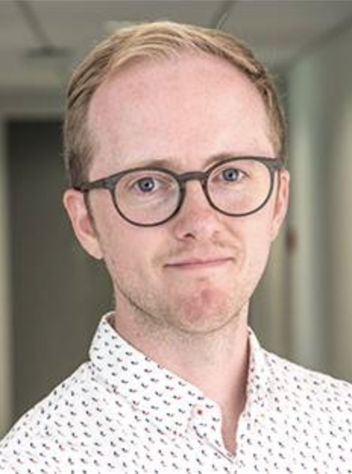
2004 MChem Medicinal Chemistry, University of Edinburgh
2008 DPhil Organic Chemistry, University of Oxford
2012 MRC Fellow, MRC Laboratory of Molecular Biology
2014 Marie Curie Fellow, Harvard University
2015 Visiting Fellow, MIT
2016 Marie Curie Fellow, University of Cambridge
2017 Lecturer, University of Edinburgh
2019 Visiting Professor, Caltech
2020 Senior Lecturer, University of Edinburgh
2022 Colworth Medal, Biochemical Society
2023 Professor, University of Edinburgh
2023 Norman Heatley Award, Royal Society of Chemistry

